| GEN AI LEARNING  **Complete Generative AI Learning – New Year Challenge** | WRITTEN BY: ALOY |
| --- | --- |

***Day -1***

**Section 1: Introduction**

**Creating Virtual Environment:**

* **1st Method using Python:**

Creating Python Environment Python -m venv {Folder Name}



Activate Python Environment

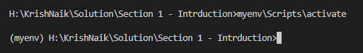

By default, only the python version install in your system will get installed in this environment. In my case it is 3.9.0

For deactivating the environment, type deactivate

* **2nd Method using VirtualEnv:**

Creating Python Environment using virtual env required virtualenv to install. So, first step is to do pip install virtualenv,



For creating environment, we have to follow below command,



Now to activate follow similar steps like before,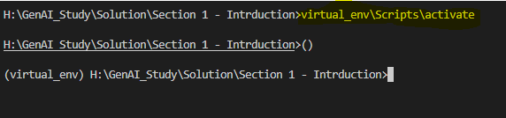

Again, here by default python version is same as previous,

To change the python version, we can try using below command,

virtualenv -p python3.10 {Virtual Env Folder Name or Virtual Environment Name}

* **3rd Method using Conda: s**

Pre-requisite is Anaconda. This should be installed in your machine.

You can try running this in **VSCode** terminal, but if you are getting below error,



Try it using conda command prompt or restart the VSCode and open a new terminal. Also remember to deactivate previous environment before running these scripts as nested virtual environment is not allowed.



To activate it,



**Selecting Kernel in IPYNB file in VSCode:**

Follow below URL for further query,

<https://code.visualstudio.com/docs/datascience/jupyter-kernel-management>

**Note:** If need to run the code in jupyter notebook we need to install **ipykernel** which is the base package

**Some basic installation to start with are as follows,**

One way to install those using pip command like,

pip install ipykernel => likewise for each library we can run each single command, or we can run single line command placing all the library name with space separated like below,



There is another way to do the installation is using requirements.txt file, where you can keep all the required package in each line like,

and then run below command,



**Section 2: Python Basics**

Below are Python basic which covers, Basic Syntax, Variable, Datatype, Operator.

**Code Files:**



**Section 3: Python Control Flow**

Below are the items mentioned in the code block,

